ADOS-2 Conference Summary Report- 1/16/17
Training dates: 1/11/18-1/12/18

I am very grateful to have had the privilege to participate in the ADOS-2 Clinical Training Workshop, which was offered at the 25th Annual CARD Conference in St. Petersburg, FL. The training was led by Dr. Cathy Rice, Director of the Emory Autism Center in Atlanta, GA. Dr. Rice shared her expertise on Autism Spectrum Disorder (ASD), including diagnostic criteria, common features of ASD, and classification of ASD using the ADOS-2. She also provided an overview of how to administer the ADOS-2, including tips for setting up the environment, coding specific behaviors, scoring, and interpreting the results. Finally, Dr. Rice conducted 2 live administrations of the ADOS-2, one with a 29 month-old child and one with a 32 year-old man. During the live administrations, participants were able to code the examinees’ responses and then score the ADOS-2 independently. Dr. Rice then reviewed her own codes and scores with participants, providing explanations of why she coded things a certain way. Overall, Dr. Rice’s insights into Autism Spectrum Disorder as well as her expertise in administration of the ADOS-2 made for an ideal learning experience.

This was an extremely valuable training, which increased my understanding of how to recognize and diagnose Autism Spectrum Disorders, and how to use the ADOS-2 as a clinical tool when evaluating children and adults who are suspected to have ASD. Through the combination of videos, live demonstrations, and teaching from Dr. Rice, I gained a better understanding of how to create social situations in order to assess an individual’s social awareness, interest, and insight. I also learned how to better determine the level of need for children and adults who meet criteria for Autism Spectrum Disorders. The knowledge and experience I gained through this training will be extremely valuable in my future career as a school psychologist, as I work with children who have been diagnosed with Autism Spectrum Disorders as well as those who have yet to be identified but may be in need of intervention.

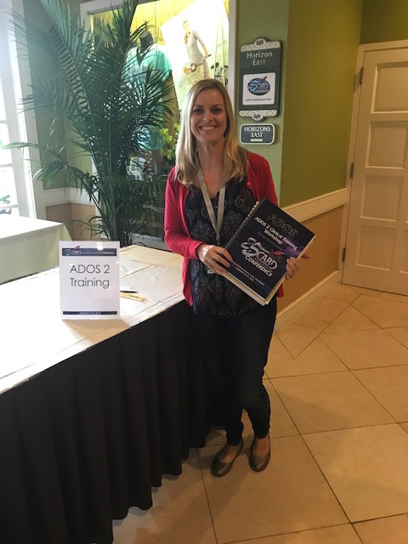
Thank you to FCIC for providing me with this wonderful training opportunity! I look forward to using the knowledge and skills I have gained from this training during my practicum at the ICEI Clinic and also in my future work as a school psychologist.

~Tara Delach, M.A.
USF School Psychology Doctoral Student & FCIC Trainee

